Village of Palmyra

Yard Waste Disposal Site

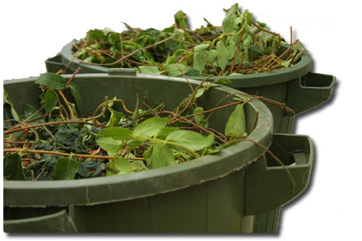
Yard Waste drop off is available to Village residents. No drop offs from lawn or tree care companies.

Proof of residency is required.
Yard Waste Site located at 430 Jefferson Street.
Hours of operation:
First Saturday of each month April – Nov.
8:00 a.m. to 12:00 p.m.
~ Deposits or dumping of material outside of scheduled dates is subject to fines outlined in Village
Ordinance.
~ All materials must be removed from bags, bins, cans or other similar containers when dropped off and cannot be bound or bundled together.

Items accepted for Yard Waste deposit

- Grass clippings and sod edgings
- Plants, weeds and garden refuse
- General yard debris and refuse
- Small twigs and branches
- Treated lumber, railroad ties and construction materials are NOT allowed for deposit
Electronic waste is no longer accepted in general garbage pickup. The Village has set up E-recycling event that is available for residents. Call 262-495-8316 for that date or go to www.villageofpalmyra.com/garbage-recycling-info/
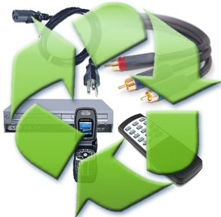
For more information about Yard Waste or E-Waste Recycling contact
the Village Hall at 495-8316 or the DPW at 495-4106. Rev. 8/13

